AI FIT TRACK
Team ID : SWTID-2026-1761
Team Size : 4
Team Leader : J YUVARAJ
Team member : yuvan raj m
Team member : Thouseef
Team member : saran raj m

1. Abstract
AI Fit Track is an AI-powered fitness tracking application designed to simplify workout management and provide personalized fitness guidance. The system allows users to securely register and log in, manage workout records, search workout history, and receive AI-based workout recommendations and fitness insights. The backend is developed using Node.js, Express.js, MongoDB, and Mongoose, with Google Gemini AI used for intelligent recommendations.
2. Introduction
Fitness users often maintain workout records manually, making it difficult to organize history and understand progress. AI Fit Track provides a centralized system for recording workouts and obtaining personalized guidance. The application combines secure authentication, workout management, database storage, and AI assistance in one system.
3. Problem Statement
- Difficulty maintaining a centralized workout history.
- Manual tracking can make workout records difficult to manage.
- Lack of personalized workout recommendations.
- Difficulty understanding overall workout performance.
4. Objectives
- Provide secure user registration and login.
- Allow users to add, view, update, delete, and search workouts.
- Store workout information securely in MongoDB.
- Generate personalized workout recommendations using Google Gemini AI.
- Provide AI-generated fitness insights from workout statistics.
5. Main Modules
Authentication Module: Handles user registration, login, password protection, and JWT-based authentication.
Workout Management: Allows authenticated users to create, view, update, and delete workout records.
Workout Search: Allows users to search workouts using workout name, category, or date.
AI Recommendation: Uses Google Gemini AI to generate workout suggestions based on age, fitness goal, and experience level.
Fitness Insights: Analyzes workout statistics such as total workouts, average duration, and calories burned to provide personalized insights.
6. Technologies Used
- Node.js – Backend runtime environment
- Express.js – REST API framework
- MongoDB – NoSQL database
- Mongoose – MongoDB object modeling
- JWT – User authentication
- bcrypt.js – Password encryption
- Google Gemini AI – AI recommendations and fitness insights
- Postman – API testing
- Visual Studio Code – Development environment
7. System Architecture
AI Fit Track follows a modular MVC-based architecture. The client sends requests to the Express server. Protected requests are verified using JWT authentication middleware. Controllers process requests and communicate with Mongoose models for MongoDB operations or with the Gemini AI service for AI features. The system returns structured JSON responses to the client.
8. Database Design
The system mainly uses two collections: Users and Workouts. A user can have multiple workout records, creating a one-to-many relationship. User data includes name, email, encrypted password, and timestamps. Workout data includes user reference, workout name, category, duration, calories burned, workout date, and timestamps.
9. Implementation and Testing
The backend is implemented as RESTful APIs. Authentication APIs are tested first, followed by workout APIs and AI APIs. Postman can be used to verify request handling, authentication, CRUD operations, search, AI workout recommendations, and fitness insights.
10. Conclusion
AI Fit Track provides a simple and secure solution for workout tracking with AI-assisted fitness guidance. By combining MongoDB-based workout management, secure authentication, and Google Gemini AI, the system helps users organize their workout history and receive personalized recommendations.
11. Future Enhancements
- Nutrition tracking
- BMI calculation
- Wearable device integration
- Workout reminders
- Fitness analytics dashboard
12. References
Project reference document: FitTrack AI – Personalized fitness recommendations powered by AI. Technologies and architecture described are based on the supplied project reference document.
13. Scope of the Project
The project is intended for users who want to maintain workout records and receive basic personalized fitness guidance. The system can be extended later for nutrition, wearable devices, reminders, and analytics.
14. Functional Requirements
- User registration and login.
- JWT-protected access to personal workout data.
- Create, view, update, and delete workout records.
- Search workouts by name, category, or date.
- Generate AI-based workout recommendations.
- Generate AI-based fitness insights.
15. Non-Functional Requirements
- Security: passwords are protected and protected APIs use JWT authentication.
- Reliability: centralized error handling provides meaningful API responses.
- Maintainability: MVC and modular services separate responsibilities.
- Scalability: the modular backend can be extended with additional fitness features.
16. User Flow
Register → Login → Receive JWT Token → Access Protected APIs → Add/View/Search/Update/Delete Workouts → Request AI Recommendation or Fitness Insight → Receive JSON Response.
17. Output Screenshots
The following screenshots are included from the supplied FitTrack AI project document as evidence of project development and API execution.
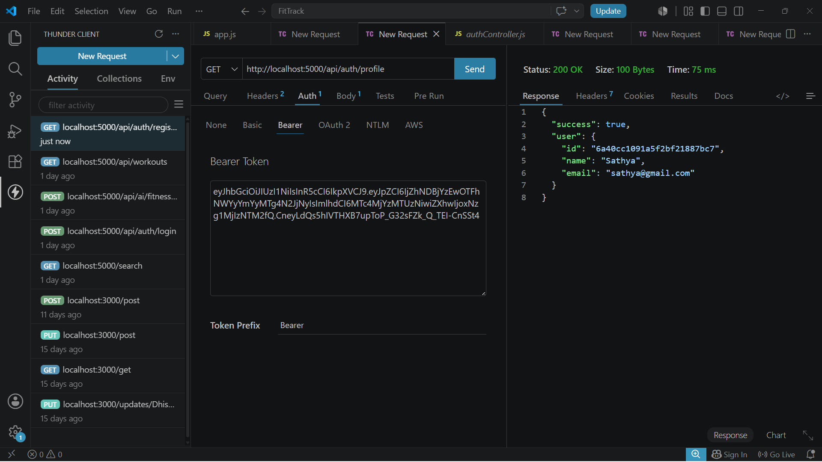
API request and response screen

Get All Workouts API output
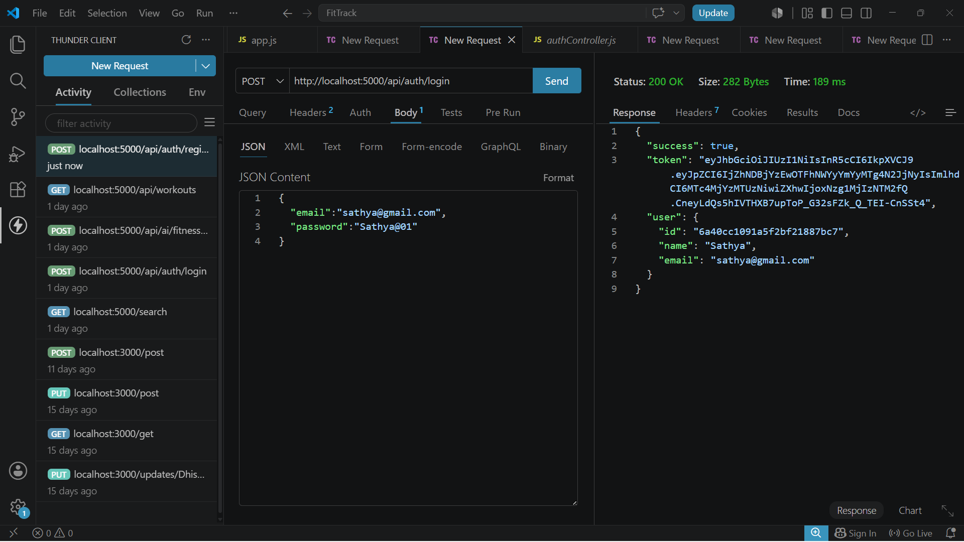
Workout API testing screen

API testing response

API testing response

API testing screen

API testing response

API testing response
18. Result
The implemented system provides secure authentication, workout management, database storage, and AI-assisted fitness guidance through REST APIs. The supplied API testing screenshots demonstrate successful interaction with the backend.

